_

Q1] Introduction to various Python libraries for machine learning a. NumPy b. Pandas c. Matplotlib d. Seaborn e. Scikit learn

# Import the quired libraries import numpy as np

import pandas as pd

import matplotlib.pyplot as plt import seaborn as sns

from sklearn.datasets import load_iris

from sklearn.model_selection import train_test_split from sklearn.ensemble import RandomForestClassifier

from sklearn.metrics import accuracy_score, confusion_matrix

# NumPy: Introduction

print("a. NumPy - Numerical Python") arr = np.array([1, 2, 3, 4, 5]) print("Sample NumPy array:", arr) print("Array Shape:", arr.shape) print("Array Sum:", np.sum(arr)) print("\n")

# Pandas: Introduction

print("b. Pandas - Data Analysis Library")

data = {'Name': ['Alice', 'Bob', 'Charlie', 'David'],

'Age': [25, 30, 22, 35]} df = pd.DataFrame(data) print("Sample Pandas DataFrame:") print(df)

print("Summary Statistics:") print(df.describe()) print("\n")

# Matplotlib: Introduction

print("c. Matplotlib - Data Visualization Library")

x = np.linspace(0, 2 * np.pi, 100)

y = np.sin(x) plt.figure() plt.plot(x, y)

plt.title("Sine Wave") plt.xlabel("x") plt.ylabel("sin(x)") plt.show()

print("\n")

# Seaborn: Introduction

print("d. Seaborn - Statistical Data Visualization Library")

iris = sns.load_dataset("iris") sns.pairplot(iris, hue="species") plt.show()

print("\n")

# Scikit-Learn: Introduction

print("e. Scikit-Learn - Machine Learning Library")

# Load a sample dataset (Iris dataset)

iris = load_iris()

X, y = iris.data, iris.target

# Split the dataset into training and testing sets

X_train, X_test, y_train, y_test = train_test_split(X, y, test_size=0.2, random_state=42)

# Train a Random Forest Classifier

clf = RandomForestClassifier(n_estimators=100, random_state=42)

clf.fit(X_train, y_train)

# Make predictions and calculate accuracy y_pred = clf.predict(X_test)

accuracy = accuracy_score(y_test, y_pred)

print("Random Forest Classifier Accuracy:", accuracy)

# Generate a confusion matrix

conf_matrix = confusion_matrix(y_test, y_pred)

print("Confusion Matrix:")

print(conf_matrix)

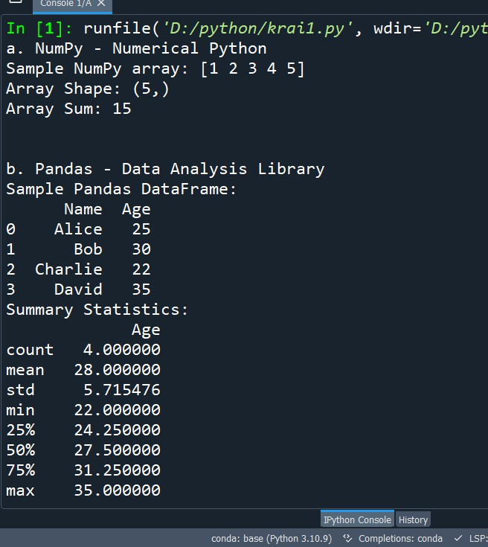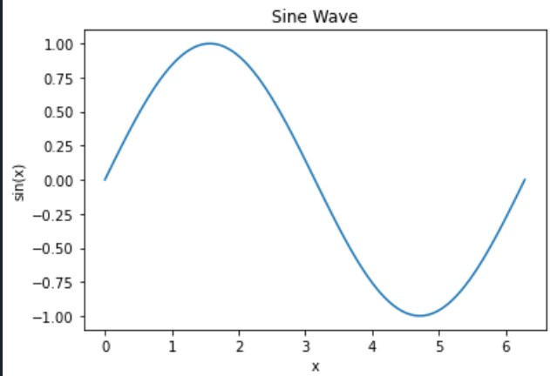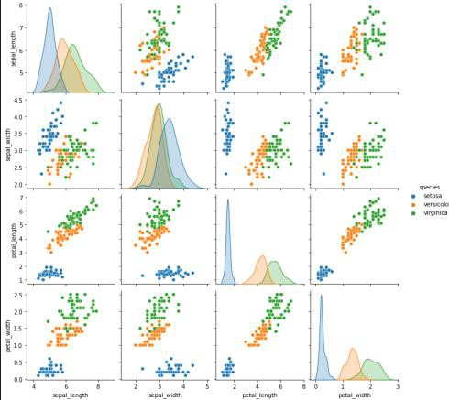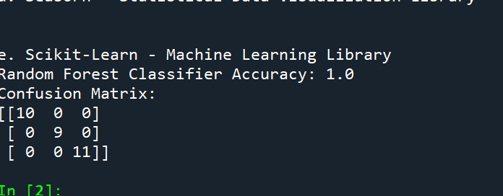

4

Q2] Write a program to find the correlation matrix import pandas as pd

data = {

'A': [1, 2, 3, 4, 5],

'B': [5, 4, 3, 2, 1],

'C': [2, 3, 1, 4, 5],

}

df = pd.DataFrame(data) correlation_matrix = df.corr() print("Correlation Matrix:") print(correlation_matrix)

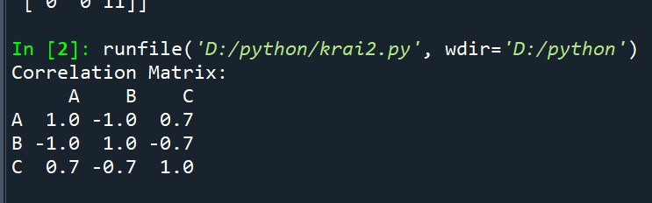

Q3] Write a program to Plot the correlation plot on dataset and visualize giving an overview of relationships among data on iris data.

import seaborn as sns

import matplotlib.pyplot as plt iris = sns.load_dataset("iris") correlation_matrix = iris.corr() plt.figure(figsize=(8, 6))

sns.heatmap(correlation_matrix, annot=True, cmap="coolwarm", linewidths=0.5)

plt.title("Correlation Plot of Iris Dataset")

plt.show()

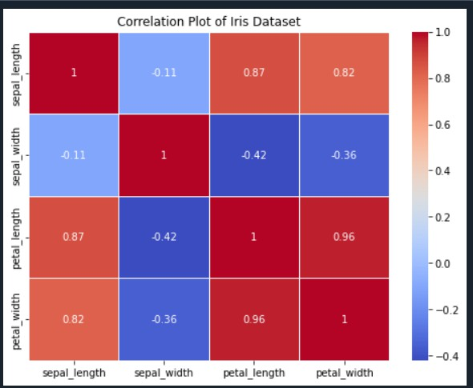

Q4] Write a program to implement Analysis of covariance: variance (ANOVA) on IRIS

dataset

import pandas as pd

from scipy.stats import f_oneway

iris = pd.read_csv("https://raw.githubusercontent.com/mwaskom/seaborn- data/master/iris.csv")

grouped_data = [group["sepal_length"] for name, group in iris.groupby("species")]

f_statistic, p_value = f_oneway(*grouped_data)

alpha = 0.05

print("One-way ANOVA Results:") print(f"F-statistic: {f_statistic:.2f}") print(f"P-value: {p_value:.4f}")

if p_value < alpha:

print("Reject the null hypothesis. There are significant differences in means.")

else:

print("Fail to reject the null hypothesis. There are no significant differences in means.")

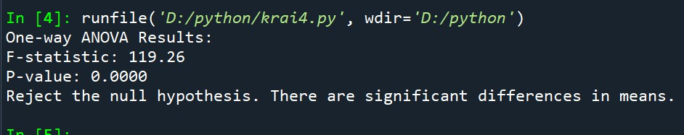

Q5] Write a program to implement linear regression algorithm to create and evaluate a model on a given dataset

import numpy as np import pandas as pd

from sklearn.datasets import fetch_openml

from sklearn.model_selection import train_test_split from sklearn.linear_model import LinearRegression

from sklearn.metrics import mean_squared_error, r2_score import matplotlib.pyplot as plt

california_housing = fetch_openml(name="california_housing", as_frame=True)

data = california_housing.frame target = data["target"]

X_train, X_test, y_train, y_test = train_test_split(data, target, test_size=0.2, random_state=42)

model = LinearRegression() model.fit(X_train, y_train) y_pred = model.predict(X_test)

mse = mean_squared_error(y_test, y_pred)

r2 = r2_score(y_test, y_pred)

print("Mean Squared Error: {:.2f}".format(mse))

print("R-squared (Coefficient of Determination): {:.2f}".format(r2))

plt.scatter(y_test, y_pred) plt.xlabel("Actual Values") plt.ylabel("Predicted Values")

plt.title("Actual vs. Predicted Values in Linear Regression")

plt.show()

Q6] Write a program to classify the given dataset using logistic regression and evaluate the model

import numpy as np import pandas as pd

from sklearn.model_selection import train_test_split from sklearn.linear_model import LogisticRegression

from sklearn.metrics import accuracy_score, classification_report, confusion_matrix data = pd.DataFrame({

'Feature1': [1.2, 2.4, 1.5, 3.5, 2.7, 4.8, 3.2, 5.1, 4.0, 6.2],

'Feature2': [0, 1, 0, 1, 0, 1, 0, 1, 0, 1],

'Target': [0, 1, 0, 1, 0, 1, 0, 1, 0, 1]

})

X = data[['Feature1', 'Feature2']]

y = data['Target']

X_train, X_test, y_train, y_test = train_test_split(X, y, test_size=0.2, random_state=42)

model = LogisticRegression() model.fit(X_train, y_train) y_pred = model.predict(X_test)

accuracy = accuracy_score(y_test, y_pred)

print("Accuracy:", accuracy)

classification_rep = classification_report(y_test, y_pred)

print("Classification Report:")

print(classification_rep)

conf_matrix = confusion_matrix(y_test, y_pred)

print("Confusion Matrix:")

print(conf_matrix)

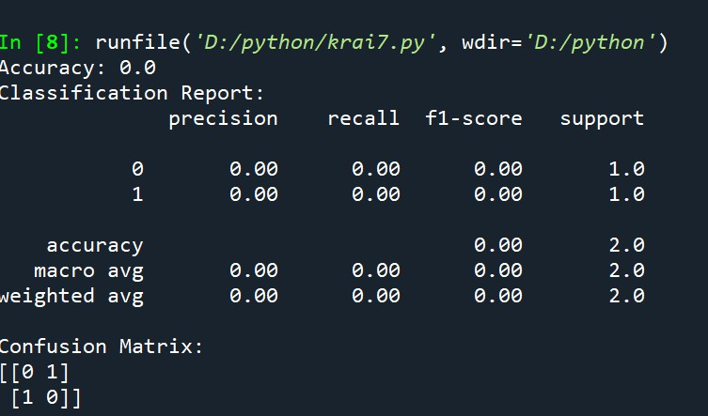

Q7] Write a program to implement support vector machine algorithm import numpy as np

import pandas as pd

from sklearn.model_selection import train_test_split from sklearn.svm import SVC

from sklearn.metrics import accuracy_score, classification_report, confusion_matrix data = pd.DataFrame({

'Feature1': [1.2, 2.4, 1.5, 3.5, 2.7, 4.8, 3.2, 5.1, 4.0, 6.2],

'Feature2': [0, 1, 0, 1, 0, 1, 0, 1, 0, 1],

'Target': [0, 1, 0, 1, 0, 1, 0, 1, 0, 1]

})

X = data[['Feature1', 'Feature2']]

y = data['Target']

X_train, X_test, y_train, y_test = train_test_split(X, y, test_size=0.2, random_state=42)

model = SVC(kernel='linear', C=1.0)

model.fit(X_train, y_train)

y_pred = model.predict(X_test)

accuracy = accuracy_score(y_test, y_pred)

print("Accuracy:", accuracy)

classification_rep = classification_report(y_test, y_pred)

print("Classification Report:")

print(classification_rep)

conf_matrix = confusion_matrix(y_test, y_pred)

print("Confusion Matrix:")

print(conf_matrix)

Q8] Write a program to implement Decision Tree model on the given dataset import numpy as np

import pandas as pd

from sklearn.model_selection import train_test_split from sklearn.tree import DecisionTreeClassifier

from sklearn.metrics import accuracy_score, classification_report, confusion_matrix data = pd.DataFrame({

'Feature1': [1.2, 2.4, 1.5, 3.5, 2.7, 4.8, 3.2, 5.1, 4.0, 6.2],

'Feature2': [0, 1, 0, 1, 0, 1, 0, 1, 0, 1],

'Target': [0, 1, 0, 1, 0, 1, 0, 1, 0, 1]

})

X = data[['Feature1', 'Feature2']]

y = data['Target']

X_train, X_test, y_train, y_test = train_test_split(X, y, test_size=0.2, random_state=42)

model = DecisionTreeClassifier()

model.fit(X_train, y_train)

y_pred = model.predict(X_test)

accuracy = accuracy_score(y_test, y_pred)

print("Accuracy:", accuracy)

classification_rep = classification_report(y_test, y_pred)

print("Classification Report:")

print(classification_rep)

conf_matrix = confusion_matrix(y_test, y_pred)

print("Confusion Matrix:")

print(conf_matrix)



Q9] Write a program to implement Bayesian classification on given dataset. import numpy as np

import pandas as pd

from sklearn.model_selection import train_test_split from sklearn.naive_bayes import GaussianNB

from sklearn.metrics import accuracy_score, classification_report, confusion_matrix data = pd.DataFrame({

'Feature1': [1.2, 2.4, 1.5, 3.5, 2.7, 4.8, 3.2, 5.1, 4.0, 6.2],

'Feature2': [0, 1, 0, 1, 0, 1, 0, 1, 0, 1],

'Target': [0, 1, 0, 1, 0, 1, 0, 1, 0, 1]

})

X = data[['Feature1', 'Feature2']]

y = data['Target']

X_train, X_test, y_train, y_test = train_test_split(X, y, test_size=0.2, random_state=42)

model = GaussianNB()

model.fit(X_train, y_train)

y_pred = model.predict(X_test)

accuracy = accuracy_score(y_test, y_pred)

print("Accuracy:", accuracy)

classification_rep = classification_report(y_test, y_pred)

print("Classification Report:")

print(classification_rep)

conf_matrix = confusion_matrix(y_test, y_pred)

print("Confusion Matrix:")

print(conf_matrix)



Q10] Write a program to implement K-Nearest Neighbor algorithm on given dataset. import numpy as np

import pandas as pd

from sklearn.model_selection import train_test_split from sklearn.neighbors import KNeighborsClassifier

from sklearn.metrics import accuracy_score, classification_report, confusion_matrix data = pd.DataFrame({

'Feature1': [1.2, 2.4, 1.5, 3.5, 2.7, 4.8, 3.2, 5.1, 4.0, 6.2],

'Feature2': [0, 1, 0, 1, 0, 1, 0, 1, 0, 1],

'Target': [0, 1, 0, 1, 0, 1, 0, 1, 0, 1]

})

X = data[['Feature1', 'Feature2']]

y = data['Target']

X_train, X_test, y_train, y_test = train_test_split(X, y, test_size=0.2, random_state=42)

model = KNeighborsClassifier(n_neighbors=3)

model.fit(X_train, y_train)

y_pred = model.predict(X_test)

accuracy = accuracy_score(y_test, y_pred)

print("Accuracy:", accuracy)

classification_rep = classification_report(y_test, y_pred)

print("Classification Report:")

print(classification_rep)

conf_matrix = confusion_matrix(y_test, y_pred)

print("Confusion Matrix:")

print(conf_matrix)



Q11] Write a program to implement K-Means algorithm on given dataset and visualize the clusters.

import pandas as pd import numpy as np

from sklearn.cluster import KMeans import matplotlib.pyplot as plt

data = pd.DataFrame({

'X1': [1, 2, 2.5, 3, 3.5, 4, 4.5, 5, 5.5, 6],

'X2': [1, 2, 3, 4, 3.5, 4.5, 5.5, 6, 5, 6]

})

K = 2

model = KMeans(n_clusters=K, random_state=42)

model.fit(data)

cluster_centers = model.cluster_centers_ labels = model.labels_ plt.figure(figsize=(8, 6))

for k in range(K):

cluster_data = data[labels == k]

plt.scatter(cluster_data['X1'], cluster_data['X2'], label=f'Cluster {k + 1}')

plt.scatter(cluster_centers[:, 0], cluster_centers[:, 1], c='black', marker='x', s=100, label='Centroids')

plt.title(f'K-Means Clustering with K={K}')

plt.xlabel('X1') plt.ylabel('X2') plt.legend() plt.show()

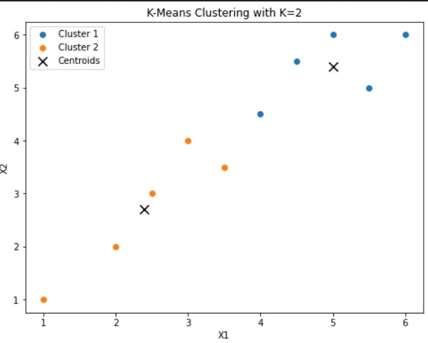

Q12] Write a program to implement deep learning algorithm using ANN

import tensorflow as tf

from tensorflow import keras

from tensorflow.keras.layers import Dense, Flatten from tensorflow.keras.datasets import mnist

import matplotlib.pyplot as plt

(x_train, y_train), (x_test, y_test) = mnist.load_data()

x_train, x_test = x_train / 255.0, x_test / 255.0 model = keras.models.Sequential([

Flatten(input_shape=(28, 28)), Dense(128, activation='relu'),

Dense(10, activation='softmax')

])

model.compile(optimizer='adam', loss='sparse_categorical_crossentropy', metrics=['accuracy'])

model.fit(x_train, y_train, epochs=5)

test_loss, test_accuracy = model.evaluate(x_test, y_test, verbose=2)

print(f"Test accuracy: {test_accuracy}") predictions = model.predict(x_test) plt.figure(figsize=(10, 10))

for i in range(25): plt.subplot(5, 5, i + 1) plt.xticks([]) plt.yticks([]) plt.grid(False)

plt.imshow(x_test[i], cmap=plt.cm.binary) predicted_label = tf.argmax(predictions[i]) true_label = y_test[i]

if predicted_label == true_label:

color = 'green' else:

color = 'red'

plt.xlabel(f"{predicted_label} ({true_label})", color=color)

plt.show()

Q13] Write a program to implement deep learning algorithm using CNN

import tensorflow as tf

from tensorflow import keras

from tensorflow.keras import layers

from tensorflow.keras.datasets import mnist import matplotlib.pyplot as plt

(x_train, y_train), (x_test, y_test) = mnist.load_data()

x_train, x_test = x_train / 255.0, x_test / 255.0 model = keras.Sequential([

layers.Input(shape=(28, 28, 1)), layers.Conv2D(32, (3, 3), activation='relu'), layers.MaxPooling2D((2, 2)), layers.Conv2D(64, (3, 3), activation='relu'), layers.MaxPooling2D((2, 2)), layers.Flatten(),

layers.Dense(64, activation='relu'),

layers.Dense(10, activation='softmax')

])

model.compile(optimizer='adam', loss='sparse_categorical_crossentropy', metrics=['accuracy'])

x_train = x_train.reshape(x_train.shape[0], 28, 28, 1)

x_test = x_test.reshape(x_test.shape[0], 28, 28, 1)

model.fit(x_train, y_train, epochs=5, validation_data=(x_test, y_test)) test_loss, test_accuracy = model.evaluate(x_test, y_test, verbose=2) print(f"Test accuracy: {test_accuracy}")

predictions = model.predict(x_test)

plt.figure(figsize=(10, 10))

for i in range(25): plt.subplot(5, 5, i + 1) plt.xticks([]) plt.yticks([]) plt.grid(False)

plt.imshow(x_test[i].reshape(28, 28), cmap=plt.cm.binary)

predicted_label = tf.argmax(predictions[i])

true_label = y_test[i]

if predicted_label == true_label:

color = 'green' else:

color = 'red'

plt.xlabel(f"{predicted_label} ({true_label})", color=color)

plt.show()

Q14] Write a program to implement deep learning algorithm using GAN

import tensorflow as tf

from tensorflow import keras

from tensorflow.keras import layers def build_generator(latent_dim):

model = keras.Sequential()

model.add(layers.Dense(7 * 7 * 128, input_dim=latent_dim))

model.add(layers.Reshape((7, 7, 128)))

model.add(layers.Conv2DTranspose(128, kernel_size=4, strides=2, padding="same"))

model.add(layers.BatchNormalization(momentum=0.8))

model.add(layers.LeakyReLU(alpha=0.2))

model.add(layers.Conv2DTranspose(64, kernel_size=4, strides=2, padding="same")) model.add(layers.BatchNormalization(momentum=0.8)) model.add(layers.LeakyReLU(alpha=0.2))

model.add(layers.Conv2D(1, kernel_size=4, padding="same", activation="tanh"))

return model

def build_discriminator(img_shape):

model = keras.Sequential()

model.add(layers.Conv2D(32, kernel_size=4, strides=2, input_shape=img_shape, padding="same"))

model.add(layers.LeakyReLU(alpha=0.2))

model.add(layers.Conv2D(64, kernel_size=4, strides=2, padding="same")) model.add(layers.BatchNormalization(momentum=0.8)) model.add(layers.LeakyReLU(alpha=0.2))

model.add(layers.Conv2D(128, kernel_size=4, strides=2, padding="same")) model.add(layers.BatchNormalization(momentum=0.8)) model.add(layers.LeakyReLU(alpha=0.2))

model.add(layers.Flatten()) model.add(layers.Dense(1, activation="sigmoid")) return model

discriminator = build_discriminator((28, 28, 1))

discriminator.compile(loss="binary_crossentropy", optimizer=keras.optimizers.Adam(0.0002, 0.5), metrics=["accuracy"])

latent_dim = 100

generator = build_generator(latent_dim)

discriminator.trainable = False

gan_input = keras.Input(shape=(latent_dim,))

x = generator(gan_input)

gan_output = discriminator(x)

gan = keras.models.Model(gan_input, gan_output)

gan.compile(loss="binary_crossentropy", optimizer=keras.optimizers.Adam(0.0002, 0.5))

def train_gan(generator, discriminator, gan, batch_size, latent_dim, num_epochs):

for epoch in range(num_epochs):

for _ in range(int(60000 / batch_size)):

noise = tf.random.normal((batch_size, latent_dim))

generated_images = generator.predict(noise)

real_images = x_train[np.random.randint(0, x_train.shape[0], batch_size)]

labels_real = np.ones((batch_size, 1))

labels_fake = np.zeros((batch_size, 1))

d_loss_real = discriminator.train_on_batch(real_images, labels_real) d_loss_fake = discriminator.train_on_batch(generated_images, labels_fake) d_loss = 0.5 * np.add(d_loss_real, d_loss_fake)

noise = tf.random.normal((batch_size, latent_dim))

labels_gan = np.ones((batch_size, 1))

g_loss = gan.train_on_batch(noise, labels_gan)

print(f"Epoch {epoch}/{num_epochs}, D Loss: {d_loss[0]}, G Loss: {g_loss}")

plot_generated_images(generator, epoch, latent_dim)

def plot_generated_images(generator, epoch, latent_dim, examples=10, dim=(1, 10), figsize=(10, 1)):

noise = tf.random.normal((examples, latent_dim)) generated_images = generator.predict(noise) generated_images = 0.5 * generated_images + 0.5 plt.figure(figsize=figsize)

for i in range(examples): plt.subplot(dim[0], dim[1], i + 1) plt.imshow(generated_images[i, :, :, 0], cmap="gray") plt.axis("off")

plt.tight_layout()

plt.savefig(f"gan_generated_image_epoch_{epoch}.png") (x_train, _), (_, _) = keras.datasets.mnist.load_data()

x_train = x_train / 127.5 - 1.0

x_train = np.expand_dims(x_train, axis=3)

train_gan(generator, discriminator, gan, batch_size=64, latent_dim=latent_dim, num_epochs=100)

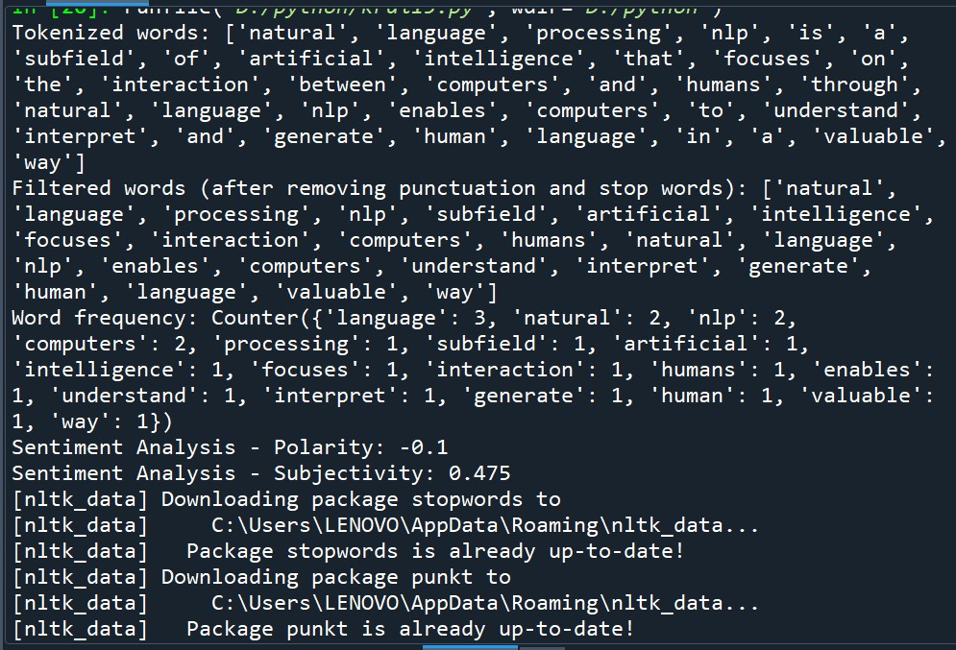

Q16] Write a program to implement web scrapping on the given URL

import requests

from bs4 import BeautifulSoup url = "https://example.com" response = requests.get(url)

if response.status_code == 200:

soup = BeautifulSoup(response.text, "html.parser")

links = soup.find_all("a")

for link in links:

print(link.get("href"))

else:

print("Failed to retrieve the webpage. Status code:", response.status_code)

